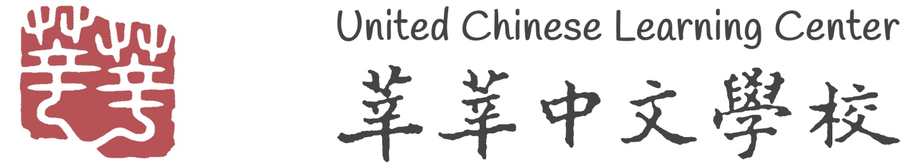

Summer 2024 Chinese Immersion Program
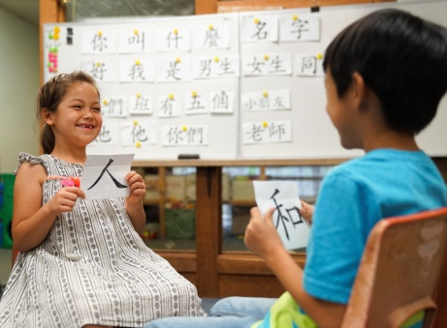
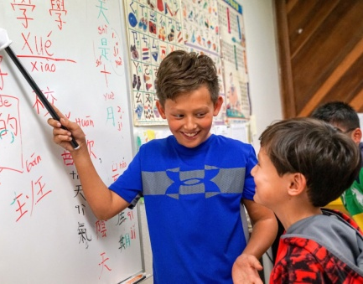
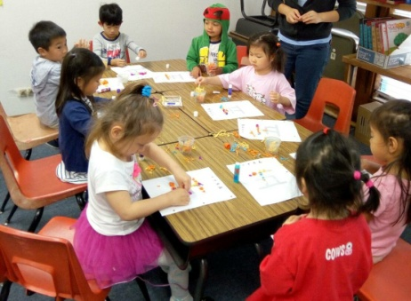

Summer Enrichment Program at United Chinese Learning Center (Huntington Beach)​

Interested in having your child learn the Chinese language and about Chinese culture this summer? United Chinese Learning Center (UCLC) is offering a half day (9:00am – 12:00pm) in-person Chinese immersion program this summer!

The program is designed for children ages 4+ and each child will be placed into smaller group classes based on their Chinese proficiency. Summer classes begin Monday, June 10, 2024. Last day of class is Friday, August 2, 2024.

Early registration ends on May 11, 2024. Tuition is $180 per week. Free early drop off starting at 8:30am.
For more information, please see our website www.uclchb.org, call UCLC at (714) 841-7587, Principal Luo at (714) 362-4616 or e-mail office@uclchb.org

United Chinese Learning Center, 6931 Edinger Ave. Huntington Beach, CA 92647

你好 (hello) 我的名字是 (my name is)
我喜歡學中文 (I like to learn Chinese)
謝謝 (thank you) 再見(goodbye)

